Interactive Lessons # 5 – Bending of Light - Refraction and Snell’s Law
Physics 2

We will be using the University of Colorado’s physics simulations called PhET interactive simulations in Physics.

Go to the phet.colorado.edu simulation “Bending Light.”

Link: Bending Light - Snell's Law | Refraction | Reflection - PhET Interactive Simulations (colorado.edu)
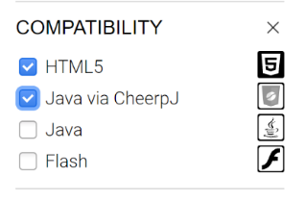

If the link does not work Google or Chrome: PhET and select “Bending Light.”

You may have to check “Java via CheepJ” to find “Bending Light.”

Click on the “Intro” tab to start the experiment
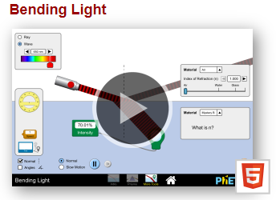
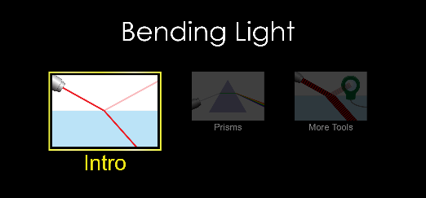

Layout of experiment for reflection and refracction
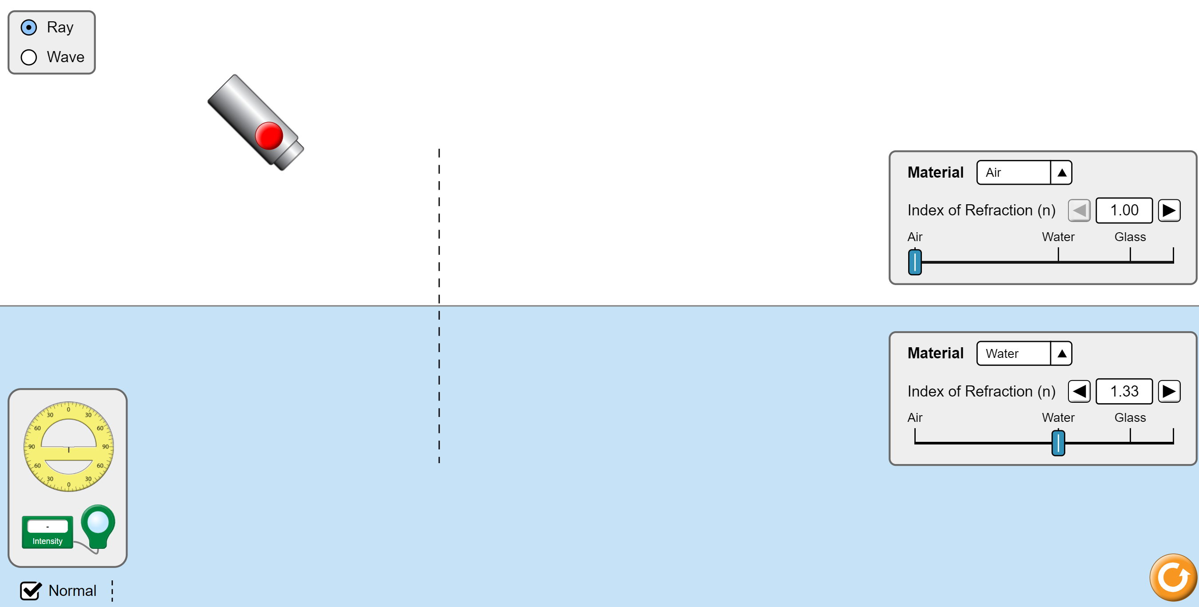
Measure angles
using Protractor
On/off for light ray
Change properties of
Incident Material
Change properties of
Transmitted Material
Incident Medium
Medium 1
Transmitted Medium
Medium 2

- Change the angle of the light ray by click hold the light source (green arrows will appear) then move to desired angle.
- Drag and drop the protractor at the dotted line with 0° along Normal line and 90° along interface of surfaces.
- Use protractor to measure the angle angles of incident, reflection, and refraction. Make sure the center of the protractor is at the interface of the light ray and surface!
- Always use the angle measured from the Normal line.
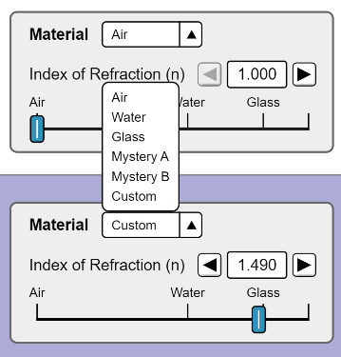
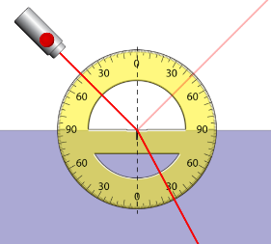
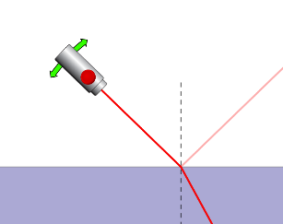

Part I – Law of Reflection

Start with light source Material as “Air” n_{air} = 1.000 and transmitted Material as “Water” n = 1.33

- Set the incident light ray to 30° from the normal line, record the value of the reflected angle below?

- Set the incident light ray to 70° from the normal line, record the value of the reflected angle below?

- Does the light obey the Law of Reflection?

- What happens to the reflected ray when the incident ray is at 0°?

RESET: Change the “Air” material to “water” so both materials are water.

- Set the incident light ray to 30° from the normal line, record the value of the reflected angle?

- Set the incident light ray to 70° from the normal line, record the value of the reflected angle?

RESET: Change the bottom material to “Air” keeping the top material as water.

- Set the incident light ray to 30° from the normal line, record the value of the reflected angle?

- Set the incident light ray to 70° from the normal line, record the value of the reflected angle?

- Was there any difference between the light ray going from “air to water” reflection and “water to air” reflection?

Part II – Refraction

RESET: Set the top material as Air and the bottom material as Glass!

- Predict which way the light ray will bend going from air to glass (towards normal or away from normal)

- Set the light ray at 60°, record the value of the angle of refraction, which way did the light ray bend?

- Compare the angle of incident and the angle of refraction, does the angle get larger or smaller?

- Calculate the angle on refraction using the values given, is it close to what you see in the simulation?

- Move the incident ray from around 1° to 89° what happens to the refracted angle and how does it compare to the incident angle?

RESET: Set the top material as Glass and the bottom material as Air!

- Predict which way the light ray will bend going from glass to air towards normal or away from normal)

- Set the ray at 30°, record the value of the angle of refraction, which way did the light ray bend?

- Compare the angle of incident and the angle of refraction, does the angle get larger or smaller?

- Calculate the angle on refraction using the values given, is it close to what you see in the simulation?

- Move the incident ray from around 1° to 89° what happens to the refracted angle and how does it compare to the incident angle?

- Calculate the critical angle for total internal reflection.

- Move the ray of light till the refracted ray is along the interface, does this angle match your calculated value for the critical angle?
Part III – Dispersion

Click the “Prisms” tab.
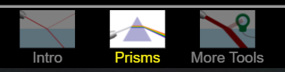

Select the white light option for the white light source.

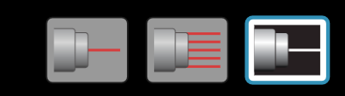

Select and drag the triangular prism from the menu at the bottom and move into the light source.

- Which color is at the top of the rainbow and explain why?

- Which color is at the bottom of the rainbow and explain why?

Reset: Remove the prism by draging back to the menu

Select and drag the circular sphere. Select the “Reflections” so that the multiple reflections appear

Move the shpere so that the incident light reflectes off the back of the shpere as shown.
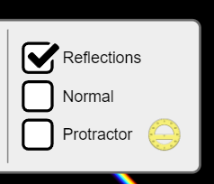
- Where does the light exiting the sphere end up?

- If you are to “see” the rainbow where would you be standing

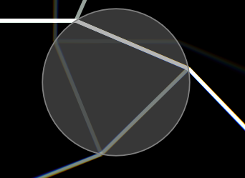

- When complete Upload this Lesson to this assignment

